**2.2. History of Robotic Arm**

The foundation of surgical robotics is in the development of the robotic arm. This is a thorough review of the literature on the nature and development of this device with emphasis on surgical applications. The published literature and classified robotic arms have been reviewed by their application: show, industrial application, medical application, etc. There is a definite trend in the manufacture of robotic arms toward more dexterous devices, more degrees-of-freedom, and capabilities beyond the human arm. Da Vinci designed the first sophisticated robotic arm in 1495 with four degrees-of-freedom and an analog on-board controller supplying power and programmability. Von Kemplen’s chess-playing automaton left arm was quite sophisticated. Unimate introduced the first industrial robotic arm in 1961, it has subsequently evolved into the PUMA arm. In 1963 the Rancho arm was designed: Minsky’s Tentacle arm appeared in 1968, Scheinma’s Stanford arm in 1969, and MIT’s Sliver arm in 1974. Aird became the first cyborg human with a robotic arm in 1993.

In 2000 Miguel Nicolalis redefined possible man machine capacity in his work on cerebral implantation in owl-monkeys directly interfacing with robotic arms both locally and at a distance. The robotic arm is the end effector of robotic systems and the hallmark feature of the Vinci Surgical System making its entrance into surgical application. But, despite the potential advantages of this computer controlled master-slave system, robotic arm have definite limitations. Ongoing work in robotics has many potential solutions to the drawbacks of current robotics surgical systems. Although surgical robotics is in its infancy, the rapid proliferation of surgical systems attests to the fact that this technology is here to stay and that urologists should brace themselves for the next wave of technology that will yet again change the way they work. Many in practice are rather started by the rapid insurgence of this sophistication technology into the armamentarium of clinical practice.

The approach in this historical review will be a bit different from that in other published accounts of robotic technology that is increasingly proliferating. The robotic arm will be the slope topic of this investigation and will be the dissected rather like the human arm. Some context will be added for literary interest but the focus will be on a sequential timeline of development and how we arrived at a piano-wire based, seven degrees-of-freedom surgical system for urology that is now sweeping across the United States.

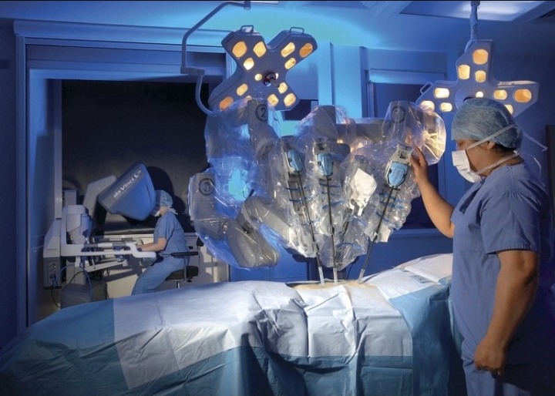

Figure 2.1. Da Vinci surgical Robotic Arm

**2.3. Various type of Robotic Arm**

There are many different types of robotic arms, but most can be characterized into one of five major categories by their mechanical structure.

* + Cartesian Robotic arm
  + Cylindrical Robotic arm
  + Parallel Robotic arm
  + SCARA Robotic arm
  + Articulated Robotic arm

2.3.1. Cartesian Robotic Arm

A robotic arm which has linear actuators cooperating with linear motors kinked to a linear axis is known as a linear robotic arm. This link can be fixed of flexible connections between the actuators and the robot. The linear motor is directly attached to the linear axis. Robotic arm which use two motors in controlling a linear axis defined gantry robotic arm. Each motor has a limited distance orthogonal to the linear axis. Ball screws follow the same principles which either use linear motor or rotary motors. This kind of robots usually achieve tasks. The manipulator of the linear robots is connected in an overhead way that allows the robotic arm to move along the horizontal plane easily, where each of these movements are perpendicular to each other and are basically defined as “x,y” for horizontal axis and sometimes “z” in case of having a vertical axis.

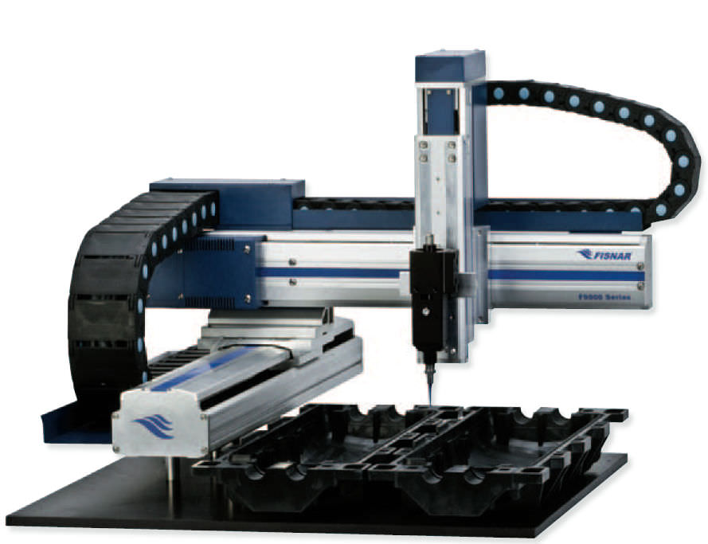

Figure 2.2. Linear Robotic Arm

2.3.2. Cylindrical Robotic Arm

Cylindrical robotic arm have two prismatic joints: one rotary joint for positioning task and the end-effector of the robot forms a cylindrical workspace. The main idea of the cylindrical robotic arm is to mount a horizontal arm which moves in forward and backward directions. The horizontal arm is linked to a carriage which goes up and down and is connected to the rotary base. Schematic cylindrical robot and its symbol figure. Since both of the units move on the base, the workspace is annular space of the cylinder. .

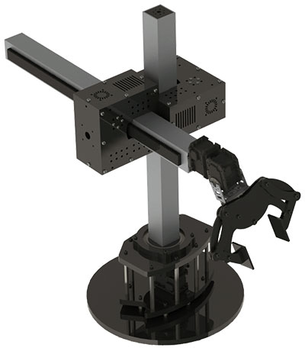

Figure 2.3. Cylindrical Robotic Arm

2.3.3. Parallel Robotic Arm

A parallel robot has an end-effector with DOF which is connected to a fixed base. The connection is done by at least two independent kinematic chains which provide the movements of the robot. A generalized parallel manipulator has a base. There exists different definitions and types of a parallel robotic arm yet the most common properties. There should not exist any mobility of manipulator when the motors are locked. There are different parallel robotic arm configurations but two kinematic design have become popular. First design is parallel robotic arm, which has tripod with three axis connection the end-effector to the movable platform and the base, and has a wrist with 2 or 3 DOF.

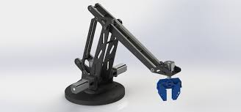

Figure 2.4. Parallel Robotic Arm

2.3.4. SCARA Robotic Arm

Selective Compliance Assembly Robotic Arm (SCARA) was first designed and invented in early 1960s in Japan. SCARA robot is perfect for the applications which require high speed and repetitive point to point movements. This is why SCARA is widely used in assembly operation. Special end-effector movement makes SCARA ideal for the tasks which require uniform motion and accelerations in a circular form. SCARA consists of two parallel rotary joints and a prismatic joint. The rotary joints can move along the horizontal plane and the prismatic joint moves along the vertical plane. One of the special characteristic of SCARA is that the robotics smooth while operating an x and y axis but very strong versus the z axis. SCARA arm is able to pick up a part vertically from a horizontally placed table and move along the assembly task by lowering the arm and placing the part at its proper location.

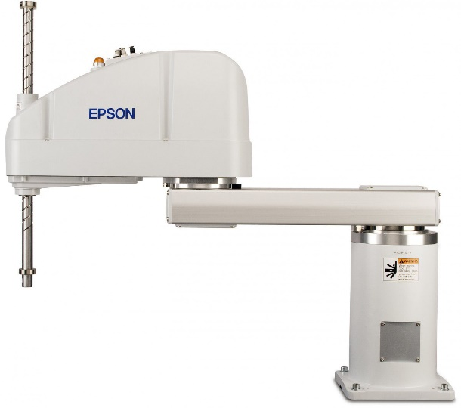

Figure 2.5. SCARA Robotic Arm

2.3.5. Articulated Robotic Arm

Articulated robot have three fixed axis connected to two revolute base. All joints of an articulated arm are revolute and most likely represent the human arm. The moving right objects are called links, revolute joints are called sliding joints. Each joint defines the relative motion of the other two object it links which determines the subset of the whole configuration space. Each configuration subset is a different position for each links. These subsets are simple to measure by considering a distance or an angle with each joint. A robotic arm can be said to be a typical example for articulated robot. An important matter which should be considered is that the dimension of the configuration space increases with the number of joints however the operation speed is limited due to the different payloads at the manipulator and nonlinear environment.

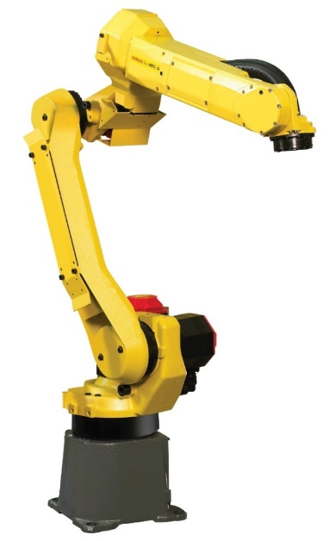

Figure 2.6. Articulated Robotic Arm

**2.4. Summary**

The introduction of the robotic arm review is described in this chapter. The design of the robotic arm will be discussed in the next chapter.